|  |  |  |  |  |  |  |
| --- | --- | --- | --- | --- | --- | --- |
|  | | Journal of Advanced Research Design | |  | | |
| Journal homepage: www.akademiabaru.com/ard.html  ISSN: 2289-7984 | |
|  | | | | | | |
| Title of Manuscript (Capital Letter of Each Word) | | | | | Open  Access | |
|  | | | | | | |
| Full Name1, Corresponding Author1,[1]*, Author2 | | | | | | |
| 1 | Department of Aeronatical, Automotive and Offfshore Engineering, Fakulti Kejuruteraan Mekanikal, Universiti Teknologi Malaysia, 81310 Skudai, Johor, Malaysia | | | | |
| 2 | Department of Mechanical Engineering, Faculty of Engineering, Kano University of Science and Technology, Wudil, Nigeria | | | | |
|  |  | | | | |
| **ARTICLE INFO** | | | **ABSTRACT** | | | |
| ***Article history:***  Received 29 October 2016  Received in revised form 1 December 2017  Accepted 9 December 2017  Available online 10 December 2017 | | | Abstract should state briefly the purpose of the research, the principal results and major conclusions. References and non-standard or uncommon abbreviations should be avoided in the abstract. The number of words should not exceed 350. | | | |
| ***Keywords:*** | | |  | | | |
| Minimum three keywords, avoid too general and too specific keywords, IS-FMTS | | | **Copyright © 2018 PENERBIT AKADEMIA BARU - All rights reserved** | | | |

**1. Introduction**

The first sentence should start here [1]. The last few decades have witnessed vast research on new types of heat transfer fluids, namely nanofluids. Nanofluid is a fluid that contains nanometer-sized solid particles. The nanofluid was introduced by Choi [2] and it has been proven to give better heat transfer efficiency compared to conventional fluids. Detailed reviews on the physical and thermal properties of nanofluids can be seen in review papers by several authors [3-5].

Second paragraph starts here. A nanofluid can be produced by dispersing metallic or non-metallic nanoparticles or nanofibers with a typical size of less than 100 nm in a base liquid.

**2. Methodology**

A model of VFE-2 model was designed and fabricated in Universiti Malaysia wind tunnel under Malaysian Ministry of Education grant, as shown in Figure 1 below [4]. The designed was exactly based on the original profile of Chu and Lucking [6] as Figure 2.

Few years later, a new research group is formed to further investigate the flow structure on the blunt-edged delta wing, the team called as Vortex Flow Experiment (VFE-2). The main objective of the VFE-2 test was to validate the results of Navier-Stokes calculations and to obtain a more detailed experimental data. The VFE-2 experiments were carried out for both sharp and blunt leading edge shape delta wing [1-3].



**Fig. 1.** Comparison of experimental measurement and Numerical studies above VFE-2 configurations at α=13° [2]

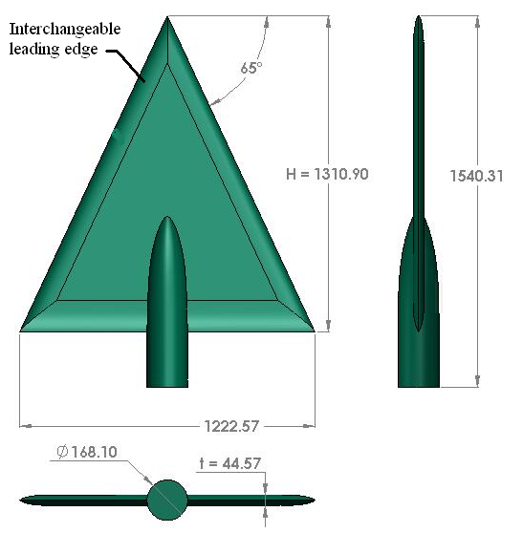

**Fig. 2.** UTM-LST delta wing VFE-2 profiles

Mat *et al*. [7] has performed a comprehensive flow visualization studies on blunt-edge delta wing. The primary vortex is developed at certain chordwise position and progress upstream with angle of attack; however there is no data in VFE-2 indicating that the vortex progressed up to the Apex region with angle of attack increases.

**3. Results**

*3.1 Pressure Distribution*

This section discusses the results obtained from the surface pressure measurement study. The effects of angle of attack, Reynolds number and leading edge bluntness are discussed in the next sub section.

*3.1.1 The effect of angle of attack*

The test configuration for this experiment is in Table 1. Nevertheless for the experiment at Reynolds number of 2×106, the angle of attack was limited to α = 23° only.

**Table 1**

The values of Reynolds number and velocity

|  |  |
| --- | --- |
| Reynolds number, Re | Velocity, V |
| 1×106 | 18 m/s |
| 2×106 | 36 m/s |

To differentiate the effects of Reynolds number, the experiments was also performed at two speeds of 18 m/s and 36 m/s that corresponding to 1×106 and 2×106 Reynolds number, calculated from Eq. 1 and summarize in Table 1.

$Re=\frac{ρVx}{μ}$ (1)

where the dynamic viscosity, μ, density of air, 𝜌 and length, *x* were taken as 1.846 ×10-5 kg/ms, 1.18 kg/m3 and 0.874 m respectively.

**4. Conclusions**

The experimental data of UTM-LST VFE-2 model at high angle of attack is presented here. More experiments are needed to verify this complicated flow topology.

**Acknowledgement**

This research was funded by a grant from Ministry of Higher Education of Malaysia (FRGS Grant R.J130000.7824.4X172).

**References (Chicago style) Minimum 15 references**

[1] Hummel, D. (2008). *Chapter 17 – The International Vortex Flow Experiment 2 (VFE-2): Objectives and Overview*. RTO-TR-AVT-113, Page 17-1 – 17-20.

[2] Luckring, J.M. and Hummel, D. (2008). *Chapter 24 – What Was Learned From The New VFE-2 Experiments*. RTO-TR-AVT-113.

[3] Mat, Shabudin Bin, Richard Green, Roderick Galbraith, and Frank Coton. "The effect of edge profile on delta wing flow." *Proceedings of the Institution of Mechanical Engineers, Part G: Journal of Aerospace Engineering* 230, no. 7 (2016): 1252-1262.

[4] Said, Mazuriah, Shabudin Mat, Shuhaimi Mansor, Ainullotfi Abdul-Latif, and Tholudin Mat Lazim. "Reynolds Number Effects on Flow Topology Above Blunt-Edge Delta Wing VFE-2 Configurations." In *53rd AIAA Aerospace Sciences Meeting*, p. 1229. 2015.

[5] Luckring, James M. "Initial experiments and analysis of blunt-edge vortex flows for VFE-2 configurations at NASA Langley, USA." *Aerospace Science and Technology* 24, no. 1 (2013): 10-21.

[6] Konrath, Robert, Christian Klein, and Andreas Schröder. "PSP and PIV investigations on the VFE-2 configuration in sub-and transonic flow." *Aerospace Science and Technology* 24, no. 1 (2013): 22-31.

[7] Fritz, Willy. "Numerical simulation of the peculiar subsonic flow-field about the VFE-2 delta wing with rounded leading edge." *Aerospace Science and Technology* 24, no. 1 (2013): 45-55.

[8] Chu, J. and Luckring, J.M. (1996). *Experimental Surface Pressure Data Obtained on 650 Delta Wing across Reynolds Number and Mach number Ranges*. NASA Technical Memorandum 4645. (Sharp-edged report)

1. * *Corresponding author.*

   *E-mail address: ali@gmail.com (Corresponding Author’s name)*