|  |  |  |  |  |  |  |
| --- | --- | --- | --- | --- | --- | --- |
|  | | Journal of Advanced Research in Occupational Safety and Health | |  | | |
| Journal homepage: www.akademiabaru.com/arosh.html  ISSN: XXXX-XXXX | |
|  | | | | | | |
| Title of Manuscript | | | | | Open  Access | |
|  | | | | | | |
| Full Name1, Corresponding Author1,[1]*, Sahnius Usman2 | | | | | | |
|  | | | | | | |
| 1 | UTM Razak School of Engineering and Advanced Technology, Universiti Teknologi Malaysia, 54100 Kuala Lumpur, Malaysia | | | | |
| 2 | Sekolah Pendidikan Profesional & Pendidikan Berterusan, Universiti Teknologi Malaysia, 54100 Kuala Lumpur, Malaysia | | | | |
|  |  | | | | |
| **ARTICLE INFO** | | | **ABSTRACT** | | | |
| ***Article history:***  Received 5 February 2018  Received in revised form 4 April 2018  Accepted 2 May 2018  Available online 1 July 2018 | | | Add abstract here. Maxmimum 300 words. Abstract should not incluce any citation. | | | |
| ***Keywords:*** | | |  | | | |
| Safety, health, risk assessment, Bow-tie, risk matrix, tunnel | | | **Copyright © 2018 PENERBIT AKADEMIA BARU - All rights reserved** | | | |

#### **Introduction**

Indent is 0.65cm [1]. Tunnels are used when highways are built across hilly or mountainous areas.In Malaysia, the longest highway maintenance concession with an overall length of 772 kilometers starts from Bukit Kayu Hitam in Kedah, Malaysia-Thai borders until Johor Bahru in the southern part of Peninsular Malaysia.

Here is the second paragraph [2]. Maintenance team is hired to maintain all these tunnel operations, especially in electrical maintenance. Highway that has been in operation also requires a risk assessment for all maintenance work so that it can be carried out safely by the maintenance team and safe for road users as well. Most fatalities in road tunnels appear to arise from ordinary traffic accidents. Norwegian data indicate that two-thirds of deaths in road tunnels are resulted from common traffic accidents and about one-third is from fire-related incidents and ‘dangerous goods’ incidents [1].

Other than that two more elements are needed in developing the Bowtie analysis namely threat, consequences and safety barriers [6].

# Methodology

The risk assessment has various tools to assess the risks based on qualitative or quantitative method. The tools used in the risk assessment is made up of Hazard Identification, Risk Assessment & Risk Control (HIRARC), System-Theoretic Accident Model and Processes (STAMP), Hazard and Operability (HAZOP), Bow-Tie, Risk Matrix and much more that can be used to suit the activity and the inherent risks.

Figure 1 shows the risk matrix of 4x4 that categorizes the likelihood and consequences by nominal textual description as references. This figure shows the use of qualitative methods for determining the probability and consequences of each of the fault tree and event tree of the critical event. As a result, the level of severity will be based on every each causal pathway as shown in Figure 2.

|  |  |  |  |  |
| --- | --- | --- | --- | --- |
|  | Insignificant Consequences | Significant Consequences | Serious Accident | Major Accident |
| Frequent |  |  |  |  |
| Probable |  |  |  |  |
| Improbable | No personal harm |  | Single Fatality and several injured | Critical Event |
| Very Improbable |  |  |  | Several Fatalities and many injured |

**Fig. 1.** The risk matrix 4x4 that will categorize the likelihood and consequences

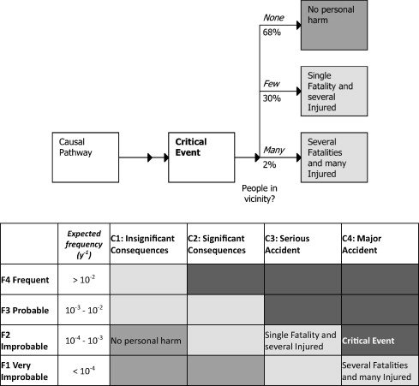

**Fig. 2.** Level of severity based on every each causal pathway [8]

1. **Results and Discussion**

All data collection was gathered based on the qualitative and quantitative analysis approach through conducting observation, interview and survey questionnaire. Based on real-time observation and feedback from the staff and technician of the maintenance tunnel team, they were not aware of the risk that could be inflicted on them as there were no risk assessment has ever been conducted. The team were not aware of the risk of working at high, confine space, live power of 11 kilovolt-ampere (kVA) and energize transformers, as well as facing the live traffic of expressway users. Most of their work involves the use of live powers from 240 volt-ampere (VA) until 11 kilovolt-ampere (kVA) (maximum transformer capacity) which could lead to fire disaster on the expressway tunnel. One discussion was conducted to get the feedback from all staff whereby relevant safety and health concerns have been raised by staff and technician. One of the feedback was related to an accident that occurred during energized power causing a small flash over to the transformer however, without causing any injuries. It was also found that, any risks arising from electrical maintenance work were thought to be common risks associated with the field of work by the technicians and the presence of danger had been compromised without any proper source of guidelines. This is due to hazard identification and risk assessment are not sufficiently introduced in a basic level of work.

**Table 1**

The risk identified from data collection

|  |  |  |  |  |  |
| --- | --- | --- | --- | --- | --- |
| **Type of Risk/Hazard** | **No.** | **Description** | **\*L** | **\*S** | **Risk Rating (*Lx*S)** |
| Safety  (Acute Impact) | 1. | Expose to unguarded moving mechanical part | 2 | 3 | Medium  (6) |
| 2. | Integrity of Scaffold – Scaffolding topple | 2 | 3 | Medium  (6) |
| 3. | Hand expose with the sharp object | 3 | 2 | Medium  (6) |
| 4. | Moving vehicle – Hit by a moving vehicle during working on scissors lift | 4 | 4 | High  (16) |
| 5. | Loose tools – falling object on road user | 4 | 3 | Medium  (12) |
| 6. | Moving vehicle – Hit by moving vehicle while setting up Traffic Management Plan (TMP) | 4 | 4 | High  (16) |
| 7. | Integrity of Fire Fighting System - Alarm system in the tunnel also not synchronize with the control room | 3 | 5 | High  (15) |
| 8. | Flash Over/ Arc Flash during switch over transformer | 3 | 5 | High  (15) |
| 9. | Unsafe Act due to the staff and contractor intended to cross the highway on live traffic – Hit moving vehicle while road crossing | 4 | 4 | High  (16) |
| 10. | Diesel Filter compartment in USP Control Room caught on fire – No warning sign of fire hazard | 2 | 4 | Medium  (8) |
| Health  (Chronic Impact) | 1. | Confined Space | 4 | 4 | High  (16) |
| 2. | Unknown airborne dust | 4 | 5 | High  (20) |
| 3. | Inappropriate PPE due to unknown airborne dust | 4 | 4 | High  (16) |

*L : Likelihood * S : Severity

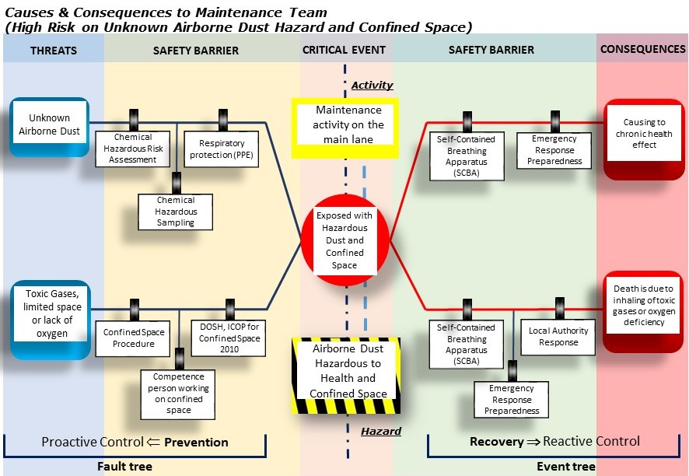

**Fig. 3.** Bow-Tie Model develop based on critical risk of unknown airborne dust hazard and confined space

1. **Conclusion**

This study focuses on the feedback given by the maintenance technicians in tunnel maintenance work of Menora Tunnel, Perak. It was found that all maintenance technicians were exposed to certain risks depending on the level of risk exposure itself. Based on the identified critical risks, safety barriers for proactive and reactive control have been determined to minimise and hopefully eliminate the threats and consequences of threats from occurring..

**References (minimum 15 reference, Chicago style)**

[1] Ingason, H., *Fire Safety in Tunnels.* Fire Technology, 2013. **49**(2): p. 433-434.

[2] Kazaras, Konstantinos, Konstantinos Kirytopoulos, and Athanasios Rentizelas. "Introducing the STAMP method in road tunnel safety assessment." *Safety Science* 50, no. 9 (2012): 1806-1817.

[3] Schlosser, František, Martin Rázga, and Peter Danišovič. "Risk Analysis in Road Tunnels." *Procedia Engineering* 91 (2014): 469-474.

[4] Ingason, Haukur. "New challenges in tunnel fire safety." (2016): 1445-1447.

[5] Van Weyenberge, Bart, Xavier Deckers, Robby Caspeele, and Bart Merci. "Development of a risk assessment method for life safety in case of fire in rail tunnels." *Fire technology* 52, no. 5 (2016): 1465-1479.

[6] de Ruijter, Alex, and Frank Guldenmund. "The bowtie method: A review." *Safety science* 88 (2016): 211-218.

[7] Jacinto, Celeste, and Cristina Silva. "A semi-quantitative assessment of occupational risks using bow-tie representation." *Safety Science* 48, no. 8 (2010): 973-979.

[8] Duijm, Nijs Jan. "Recommendations on the use and design of risk matrices." *Safety Science* 76 (2015): 21-31.

[9] McNamara, Carter. "General guidelines for conducting interviews, Minnesota." *Missouri Institute of science* (1999).

[10] Boyce, Carolyn, and Palena Neale. "Conducting in-depth interviews: A guide for designing and conducting in-depth interviews for evaluation input." (2006).

[11] Occupational Safety and Health Act 1994, Laws of Malaysia, 1994. Retrieved from http://www.dosh.gov.my/index.php/en/list-of-documents/acts/23-02-occupational-safety-and-health-act-1994-act-514/file

[12] Road Transport Act 1987, Laws of Malaysia, 2013. Retrieved from http://www.agc.gov.my/agcportal/uploads/files/Publications/LOM/EN/Act%20333%20-%20Road%20Transport%20Act%201987.pdf

[13] Occupational Health and Safety Management System (OHSMS), Department of Standards Malaysia, BS OHSAS 18001: 2007, 2007. Retrieved from http://www.jsm.gov.my/ms-1722

[14] Guidelines for Hazard Identification, Risk Assessment and Risk Control (HIRARC), Department of Occupational Safety and Health, 2008. Retrieved from http://www.dosh.gov.my/index.php/en/legislation/guidelines/hirarc-2/1846-01-guidelines-for-hazard-identification-risk-assessment-and-risk-control-hirarc-2008/file.

[15] Occupational Safety and Health (Use and Standards of Exposure of Chemicals Hazardous to Health) Regulations (2000), Federal Subsidary Legislation, 2000. Retrieved from http://www.dosh.gov.my/index.php/en/legislation/regulations-1/osha-1994-act-154/522-pua-131-2000-1/file

[16] Industry Code of Practice for Safe Working in a Confined Space (2010), Department of Occupational Safety and Health, 2010. Retrieved from http://www.dosh.gov.my/index.php/en/competent-person-form/occupational-health/codes-of-practice/industrial-hygiene/593-industry-code-of-practice-for-safe-working-in-a-confined-space-2010?path=codes-of-practice/industrial-hygiene

1. * *Corresponding author.*

   *E-mail address: email@utm.my (Name)*