|  |  |  |  |  |  |  |
| --- | --- | --- | --- | --- | --- | --- |
|  | | Journal of Futuristic Biosciences and Biomedical Engineering | | Journal-of-Futuristic-Biosciences-and-Biomedical-Engineering | | |
| Journal homepage: www.akademiabaru.com/fbbe.html  ISSN: XXXX-XXXX | |
|  | | | | | | |
| A Sensitive DNA Biosensor using Screen Printed Gold Electrode Interdigitated Electrode (IDE) Pattern based for Identification of Human *Papillomavirus* Type 18 Variants | | | | | Open  Access | |
|  | | | | | | |
| Nor Azizah Parmin1,[1]*, Uda Hashim1,2, Subash C.B. Gopinath1,3, Zulida Rejali4, Amilia Afzan4, Muhammad Nur Aiman Uda3 | | | | | | |
| 1 | Institute of Nano Electronic Engineering, Universiti Malaysia Perlis, 01000 Kangar, Perlis, Malaysia | | | | |
| 2 | School of Microelectronic Engineering Universiti Malaysia Perlis, 01000 Kangar, Perlis, Malaysia | | | | |
| 3 | School of Bioprocess Engineering, Universiti Malaysia Perlis, 02600 Arau, Perlis, Malaysia | | | | |
| 4 | Department of Obstetrics and Gynaecology (O&G), Faculty of Medicine & Health Sciences, Universiti Putra Malaysia, 43400 UPM Serdang, Selangor | | | | |
|  |  | | | | |
| **ARTICLE INFO** | | | **ABSTRACT** | | | |
| ***Article history:***  Received 29 February 2019  Received in revised form 12 April 2019  Accepted 19 April 2019  Available online 21 April 2019 | | | A novel biosensor based Interdigitated Electrode (IDE) method for the screening of human papillomavirus (HPV) 18 was developed due to Polymerase Chain Reaction (PCR) and sequencing as conventional methods take several weeks to complete. The surface modification technique using APTES has been used in this study as a linker with the specific HPV 18 DNA probe. The electrode surface was functionalized with the 30 mer DNA probes based on the HPV 18 virus sequence. HPV18 probe was attached covalently on the glass substrate using gold microelectrode IDE pattern. Moreover, this technique can allow the immobilization of DNA on the surface of the interdigitated electrodes. Then, the utility of the method is demonstrated by immobilizing probe DNA on the surface and detecting target DNA specific for the HPV via interdigitated electrode biosensor. In our perception, this surface modification method can enables high-performance sensing for DNA immobilization to the target (analyte) DNA. | | | |
| ***Keywords:*** | | |  | | | |
| Biosensor, human papillomavirus (HPV), cervical cancer, interdigitated electrode (IDE), Immobilization, hybridization | | | **Copyright © 2019 PENERBIT AKADEMIA BARU - All rights reserved** | | | |

**1. Introduction**

Human *Papillomavirus* (HPV) 18 is the second most variant infection of cervical cancer after HPV 16 [1-3]. HPV 18 is the most aggressive one compared to other variant types [4]. HPV is the most common virus that will spread when the person have been through sexual contact [5]. About 80% of HPV virus occurred in most of countries which causes 260 000 deaths every year [6]. There are more than 100 types of HPV virus than have been discovered so far and some types can cause health problems including genital warts and cancer [7,8]. About 15 types of HPV virus has been discovered which can cause higher risk cervical cancer to women. The other types of HPV are responsible for non-genital warts, which are not sexually transmitted. There are two categories of HPV types that can sexually transmit. Firstly, is low-risk HPV. It will not cause cancer but can cause the skin wart which is known as condylomata acuminate around the genitals and anus. Mostly, high-risk HPV infection occurred without any symptoms and the development of cervical cancer take 1-2 years.

HPV 18 is the second most carcinogenic HPV type after HPV 16. HPV 18 is known as a higher proportion of cervical adenocarcinomas (ADC) which is about 37% compared with squamous cell carcinomas (SCC) which is about 12% [9]. Most of the HPV 18 are asymptomatic and capable to avoid clearance by the immune system [10,11]. Thus, the early detection method for HPV 18 DNA is necessary to develop in order to prevent the cancer for people [12].Usually, the HPV virus are related to the women that have sexual behavior such as like to change sexual partner which have the high risk to get infected by cervical cancer [13].

The IDE was composed of two connections on tracks on the glass substrate [14]. The configuration of this IDE which is to enhance the sensitivity and detection limits. There are many types of IDE have developed nowadays as shown in Figure 1. These IDEs offer several advantages, such as working with low volumes of sample and avoiding tedious polishing of solid electrodes. The IDE configuration typically enhances sensitivity and detection limits. They are suitable for decentralized assays, to develop specific biosensors and other electrochemical studies. IDE also low cost, ease of fabrication process and have excellent sensitivity which widely used in biological and chemical sensor. Besides that, this IDE have a lot of advantages in sensing application. This is because its electrodes are rigidly fixed on the substrate which can enables highly reproducible, facile application and well-quantified electrical stimulation. Furthermore, IDE also can be easily fabricated by the researcher and only need low voltage to create the electrical field strength. Currently, the IDE Nano biosensor has been developed in order to detect the cervical cancer using deoxyribonucleic acid (DNA) hybridization [15,16] The nanoscale IDE has been created to investigate the miniature and sensitive affinity biosensors.

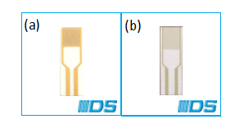

**Fig. 1.** The diagram shows the types of Interdigitated Electrode (IDE): (a) Interdigitated Gold Electrodes over glass substrate. (b) Gold interdigitated electrodes over transparent flexible plastic substrate. DropSens interdigitated electrodes (IDEs) are composed of two interdigitated electrodes with two connection tracks, on a glass substrate.

**2. Methodology**

The IDE dimensions for band gaps are200µm [17]. The glass substrate dimensions for IDE is 22.8 mm (length) x 7.6 mm (wide) x H 1 mm (height). The IDE have been purchased from Dropsens (<http://www.dropsens.com/en/interdigitated_electrodes.html>). 3-Aminopropyl triethoxysilane (APTES; C9H23NO3Si) which was the organosilane have been acquired from Sigma–Aldrich (<http://www.sigmaaldrich.com/malaysia>). The active site surface will be covered with amino groups from APTES.The biomarker using probe DNA HPV 18 (Accession No.: A18875.1) were identified by modified at 5’ end carboxylic group single-stranded 30 mer synthetic probe designed from HPV 18 strain full genomic. The design oligomers were synthesized from AIT Biotech, Singapore (http://www.aitbiotech.com). The sequence of 30-mer oligonucleotide probe, complementary (positive strand), non-complementary and mismatch oligonucleotides are showed in Table 1.

The lyophilized DNA samples were reconstituted and diluted in distilled water before using it. The 30 mer probe was utilized for immobilization and 30 mer complementary strands as a target for hybridization. The E6 region of HPV 18 nucleotide gene sequence used to design the probe in this study was gotten from previously reported complete, coding sequences (CDS) in GenBank database. The whole genomic sequence can be found in GenBank (<http://www.ncbi.nlm.nih.gov/nuccore/K02718.1>). The different pH buffer solutions were purchased from Sigma Aldrich (http://www.sigmaaldrich.com/malaysia).

**Table 1**

DNA sequences for HPV18

|  |  |
| --- | --- |
| Oligonucleotide | Sequences |
| HPV DNA probe oligonucleotide | 5’AGTGAATTCTTCGAACACTTCACTGCAAGA3’ |
| Target 30-mer HPV18A-CMP | 5’TCTTGCAGTGAAGTGTTCGAAGAATTCACT3’ |
| Non-complementary 30-mer HPV18A-NCMP | 5’AGAACGTCACTTCACAAGCTTCTTAAGTGA3’ |
| Mismatch 30-mer HPV18A-MISMATCH | 5’TCTTGCAGTGAAGAGTTCGAAGAATTCACT3’ |

Silanization of IDE using APTES Silanization was the process that covered the surface of the device with organo-functional molecules (chloro or alkoxysilane). The APTES was used as a surface modification or silanization since the deoxyribonucleic acid (DNA) cannot directly bond with the device surface. Besides that, APTES also provide a linker or molecular binding with the specific HPV 18 DNA probe for bio functionalized. The silanization is one of the techniques that are suitable and can be used in biomedical application. When APTES undergo dilution, the IDE surface will be change into hydrophobic surface as shown in Fig 3. 12µL of APTES (100%) will be diluted with 32µL of deionized distilled water (ddH2O) to form APTES (24%). The APTES was utilized as a medium to immobilize the DNA probe on the active area of the device. The volume (1µL) of 24% of APTES was dropped on the IDE surface for 15 min of silanization incubation time and then, the electrical measurement was being done.

Before performing the actual experiment, the function of the interdigitated electrode (IDE) was measured with various pH buffer solutions which are pH1-pH6 for acidic solution and pH8-pH12 for alkaline solution. The different pH buffer solutions were purchased from Sigma Aldrich (<http://www.sigmaaldrich.com/malaysia>). The pH characterization must be performed to stabilize the devices for detection of immobilization and hybridization of HPV18 DNA that caused cervical cancer. Then, the electrical test was taken with various pH solutions to observe the response of the device with different pH value. The IDE device was cleaned by using deionized distilled water (ddH2O) and dried it before pH characterization started. The device’s electrical response was obtained for bare IDE. Then, 1µL of 24% APTES (3-Aminopropyl triethoxysilane) was dropped onto the active area of the IDE surface for 15 minutes and performed the electrical response. After that, 1µL of each various pH buffer solution was dropped onto the active area of IDE surface and the I-V measurement was performed. Before changing the testing solution, the device surface must be cleaned by using ddH2O. The current-voltage (I-V) measurement were performed by using two-point probe with KEITHLEY 6847 Picoammeter and KEITHLEY 2450 Sourcemeter.

The amine terminated functional group in APTES was binding with the 5’end with the carboxyl group (COOH) on the DNA probe for immobilization. The dilution of 10µM of probe DNA was performed by using formula shown in Equation 1,

M1V1 = M2V2 (1)

where M1 = the concentration in molarity (moles/Liters) of the concentrated probe solution, V1 = the volume of the concentrated probe solution, M2 = the concentration in molarity of the dilute probe solution, and V2 = the volume of the dilute solution.

Hybridization was the process immobilization of probe DNA to its complementary which is target and form double strand DNA. This process was performed in the room temperature. Hybridization was started when the immobilization of probe DNA started. Before the hybridization process were performed, the HPV DNA analyte which were target, non-complementary and mismatch will be diluted with deionized distilled water to get appropriate concentrations.

The volume (1µL) of 10µM of target DNA was dropped onto the active area of IDE surface for hybridization process. Then, the IDE device was dried and incubated for 15 minutes. The length of the target DNA same with the probe DNA which was 24 mer. Keithley 2450 Sourcemeter was used to measure the electrical characterization of the IDE. The electrode was rinsed with distilled water.

Through hybridization, the IDE electrode was heated to a specified temperature. This was followed by a gentle washing with the 0.01M of NaOH solution to denature the sample for 5 minutes. After that, the same step as before was performed using either non-complementary oligonucleotide sequence or mismatch oligonucleotide sequence during hybridization step.

**3. Results**

*3.1 Silane Layer Characterization*

There are five functional group of silanes which are 3-aminipropyltriethoxysilane (APTES), 3-aminoprophyltrimethoxysilane (APTMS), N-(2-aminoethyl)-3-aminoprophyltrimethoxysilane (AEAPTMS) and N-(6-aminohexyl) aminomethyltriethoxysilane (AHAMTES) that can used to form the stable amine-functionalized IDE substrates [18], [19]. But in this experiment, APTES was been used for silanization process because can form covalent bond with carboxylic modified end probe [20], [21]. APTES was relatively well to do for handling because it had moderate reactivity. Three hydrolysable ethoxy groups ensure a robust anchoring of the silane to the IDE surface. This process was called as surface silanization. This process has been performed in the room temperature. When the silanization process has been done, the hydrophobic condition on the substrate surface was appeared since we used the glass substrate. The end group of the surface functionalized with NH2, SH, COOH, NHS ester or epoxide is commonly used for covalent immobilization with the biomolecules. Aminosilanes were widely used as coupling agents because of their bifunctional nature. The APTES has the end group which is amine group that can enable the conjugation of the biomolecules on the IDE substrate (Fig 4). The carboxylic group modified DNA probe was forming covalent bond with the NH2 group from APTES molecule that known as amide bond [22]. Then, Si-O group which is the other end group of APTES will be reacting with the glass substrate of IDE. Furthermore, the glass substrate can control the surface reactivity from passive to active. The amino group (NH2) of APTES must be align away from the IDE surface in order to capture the higher number of biomolecules which DNA probe in this study.

*3.1.1 Detection limits of the HPV on IDEs*

The test configuration for this experiment is in Table 1. Nevertheless, for the experiment at Reynolds number of 2×106, the angle of attack was limited to α = 23° only.

By referring to the Fig. 2, it represents the I-V curves obtained from measuring the I-V characteristic HPV18. The bottom curve which the black line indicates the I-V characteristic of a bare IDE device which show a very low resistance that prove no APTES, probe or any analyte target have not been added onto the active area of IDE surface. Then, the red line represents the I-V curve for surface modification by using APTES. Next, the blue lines which represent the I-V curve that containing the APTES and probe for immobilization process. After that, the purple, green and blue-black line represents the I-V curves for analyte DNA for hybridization process. The curve for immobilization has higher value compared to the hybridization process. This is because due to the negativity of single-strand of DNA charge during immobilization process. Thus, the current flow will be increased due to the negative charge. When hybridization process occurs, the net changes between complementary nucleotide will induced the current flow.

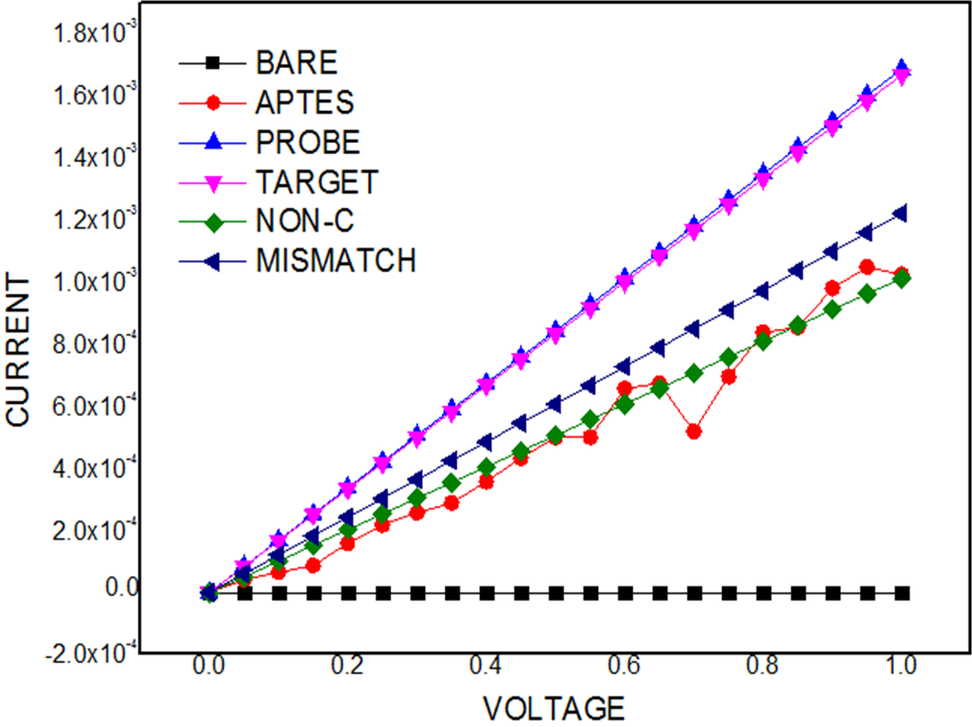

**Fig. 2.** The I-V characteristic of Interdigitated Electrode (IDE)

Based on optimization, carboxyl-probe HPV DNA which is 10µM has been introduced onto the active area of IDE surface in order to test the efficiency of different concentration of DNA target. Then, different HPV18 DNA target concentrations have been prepared which are 10µM, 10nM, 10pM and 10fM by a serial dilution using DI water. The volume 1µL of sample was taken from each concentration to test the range of detection by calculating the current. Fig. 3 showed the current measured on the biosensor with different concentration of HPV 18 DNA target by using Keithley 2450 Sourcemeter. When the current of the biosensor decrease, it showed that the hybridization process has been occurred due to the higher negative charge which comes from the attached DNA. It means the resistance will be increased in the space charge region resists the device’s current to flow.



**Fig. 3.** The current response to target DNA hybridized on the 10µM of HPV 18 DNA

The carboxyl modified probe biosensor has current which is 1.6x10-6 A at 1V. This is the requirement to set up a quantitative DNA sensor as it will not damage the DNA. These results showed that the concentration of HPV target DNA and the output current were highly related. The output currents were inversely proportional to the HPV target DNA concentration due to the electrostatic interaction between the probe and its target DNA which can affects the properties of the electrical measurement and also electrons transfer kinetics. Then, the current peak was formed a linear relationship with target concentrations over the range between 10µM and 10fM with the current value at 9.8x10-7 A to 3.8x10-7 A (Fig. 4). This will show all the analyte DNA concentration have high current sensitivity towards 10µM probe DNA, showing that more changes in charge transfer of DNA target on the sensor. Thus, it proves that our sourcemeter is more sensitive; a detection limit of 10fM can be achieved. Each detection takes lesser that 30 minutes to get a steady output current.

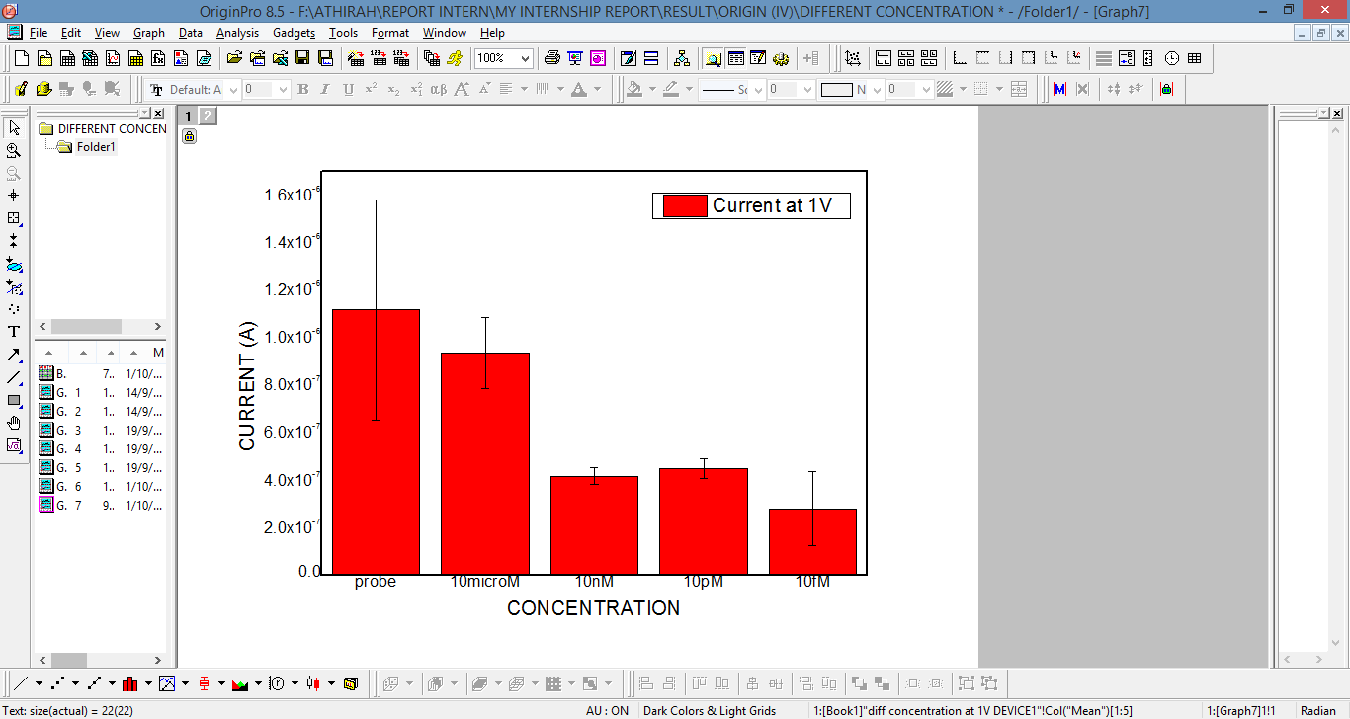

**Fig. 3.** Different concentrations (10μM to 10fM) of analyte DNA were tested. It showed different concentrations of HPV analyte DNA, have been detected using IDE nanobiosensor in order to determine the lowest concentration that can be detected. In interdigitated electrode the active area is larger enough to be disturbed by 1 V. Error bars represent the standard deviation of triplicate determinations of three independent repeated experiments (n=3).

**4. Conclusions**

The most important issue in development of high-performance biosensor is the biomolecule immobilization. The correct technique for immobilization also will lead to high performance biosensor. In order to produce uniform immobilization of DNA molecules, the current strategy of silane formation with (3-aminopropyl) triethoxysilane (APTES) has been used to modify the IDE substrate surface with stable layer of thin silane. The optimized silane layer favored will formed a uniform highly dense layer of DNA biomolecules on the substrate surface. Then, the samples were characterized for electrical properties in each step of surface modification and biomolecular immobilization by using two-point probe with Keithley 6847 Picoammeter and Keithley 2450 Sourcemeter. It is demonstrated that this picoammeter-DNA biosensor was detected as low as 10 fM of HPV analyte ssDNA, with high specificity and reproducibility. Further, the success of this spatial arrangement for DNA immobilization can be implemented in other sensors.

**Acknowledgement**

This research was funded by a grant from Ministry of Higher Education of Malaysia (FRGS Grant FRGS/2/2014/TK03/UNIMAP/01/1) and the author would like to thank all staff members of the Institute of Nanoelectronic Engineering in Universiti Malaysia Perlis for their technical advice.

**References**

[1] Parmin, Nor Azizah, Uda Hashim, and Subash CB Gopinath. "Designing probe from E6 genome region of human Papillomavirus 16 for sensing applications." *International journal of biological macromolecules* 107 (2018): 1738-1746.

[2] Agorastos, Theodoros, Kimon Chatzistamatiou, Taxiarchis Katsamagkas, George Koliopoulos, Alexandros Daponte, Theocharis Constantinidis, Theodoros C. Constantinidis, and HERMES Study Group. "Primary screening for cervical cancer based on high-risk human papillomavirus (HPV) detection and HPV 16 and HPV 18 genotyping, in comparison to cytology." *PloS one* 10, no. 3 (2015): e0119755.

[3] “Human Papillomavirus E6 biosensing_ Current progression on early detection strategies for cervical Cancer.pdf.”.

[4] Lace, Michael J., James R. Anson, Aloysius J. Klingelhutz, John H. Lee, Aaron D. Bossler, Thomas H. Haugen, and Lubomir P. Turek. "Human papillomavirus (HPV) type 18 induces extended growth in primary human cervical, tonsillar, or foreskin keratinocytes more effectively than other high-risk mucosal HPVs." *Journal of virology* 83, no. 22 (2009): 11784-11794.

[5] The American College of Obstetricians and Gynecologists, “Human Papillomavirus (HPV) Infection,” *Am. Coll. Obstet. Gynecol.* , 2014.

[6] Kay, Meera. "Screening with acetic acid could prevent 22 000 deaths from cervical cancer in India every year." *The BMJ* 346 (2013).

[7] Dochez, Carine, Johannes J. Bogers, Rita Verhelst, and Helen Rees. "HPV vaccines to prevent cervical cancer and genital warts: an update." *Vaccine* 32, no. 14 (2014): 1595-1601.

[8] Chelimo, Carol, Trecia A. Wouldes, Linda D. Cameron, and J. Mark Elwood. "Risk factors for and prevention of human papillomaviruses (HPV), genital warts and cervical cancer." *Journal of Infection* 66, no. 3 (2013): 207-217.

[9] Chen, Alyce A., Tarik Gheit, Silvia Franceschi, Massimo Tommasino, and Gary M. Clifford. "Human papillomavirus 18 genetic variation and cervical cancer risk worldwide." *Journal of virology* 89, no. 20 (2015): 10680-10687.

[10] Grabowska, Agnieszka K., and Angelika B. Riemer. "Suppl 2: The Invisible Enemy–How Human Papillomaviruses Avoid Recognition and Clearance by the Host Immune System." *The open virology journal* 6 (2012): 249.

[11] Song, Dan, Hong Li, Haibo Li, and Jianrong Dai. "Effect of human papillomavirus infection on the immune system and its role in the course of cervical cancer." *Oncology letters* 10, no. 2 (2015): 600-606.

[12] Parmin, Nor Azizah, Uda Hashim, Subash CB Gopinath, S. Nadzirah, Zulida Rejali, Amilia Afzan, and M. N. A. Uda. "Human Papillomavirus E6 biosensing: Current progression on early detection strategies for cervical Cancer." *International journal of biological macromolecules* (2018).

[13] Stock, Michelle L., Laurel M. Peterson, Amy E. Houlihan, and Laura A. Walsh. "Influence of oral sex and oral cancer information on young adults' oral sexual-risk cognitions and likelihood of HPV vaccination." *Journal of sex research* 50, no. 1 (2013): 95-102.

[14] Lakshmipriya, Thangavel, Uda Hashim, Subash CB Gopinath, and N. Azizah. "Microfluidic-based biosensor: signal enhancement by gold nanoparticle." *Microsystem Technologies* 22, no. 10 (2016): 2389-2395.

[15] Azizah, Nor, Uda Hashim, Subash CB Gopinath, and Sharipah Nadzirah. "Gold nanoparticle mediated method for spatially resolved deposition of DNA on nano-gapped interdigitated electrodes, and its application to the detection of the human Papillomavirus." *Microchimica Acta* 183, no. 12 (2016): 3119-3126.

[16] Azizah, Nor, Uda Hashim, Subash CB Gopinath, and Sharipah Nadzirah. "A direct detection of human papillomavirus 16 genomic DNA using gold nanoprobes." *International journal of biological macromolecules* 94 (2017): 571-575.

[17] “Ref. IDEAU200,” p. 33428.

[18] Hsiao, Vincent KS, John R. Waldeisen, Yuebing Zheng, Pamela F. Lloyd, Timothy J. Bunning, and Tony Jun Huang. "Aminopropyltriethoxysilane (APTES)-functionalized nanoporous polymeric gratings: fabrication and application in biosensing." *Journal of Materials Chemistry* 17, no. 46 (2007): 4896-4901.

[19] Rosenholm, Jessica M., and Mika Lindén. "Wet-chemical analysis of surface concentration of accessible groups on different amino-functionalized mesoporous SBA-15 silicas." *Chemistry of Materials* 19, no. 20 (2007): 5023-5034.

[20] A. Jones, X. Zhang, and X. Lei, “Covalent Probe Finds Carboxylic Acid,” *Cell Chemical Biology*, vol. 24, no. 5. pp. 537–539, 2017.

[21] Zhang, Yonghua, Xiaohui Geng, Junjie Ai, Qiang Gao, Honglan Qi, and Chengxiao Zhang. "Signal amplification detection of DNA using a sensor fabricated by one-step covalent immobilization of amino-terminated probe DNA onto the polydopamine-modified screen-printed carbon electrode." *Sensors and Actuators B: Chemical* 221 (2015): 1535-1541.

[22] de Figueiredo, Renata Marcia, Jean-Simon Suppo, and Jean-Marc Campagne. "Nonclassical routes for amide bond formation." *Chemical reviews* 116, no. 19 (2016): 12029-12122.

1. * *Corresponding author.*

   *E-mail address: azizahparmin@unimap.edu.my(Nor Azizah Parmin)*