|  |  |  |  |  |  |  |
| --- | --- | --- | --- | --- | --- | --- |
|  | | Malaysian Journal on Composites Science and Manufacturing | | E:\OneDrive - Universiti Teknikal Malaysia Melaka\Drive\Noraiham\UTEM\MJCSM\MJCSM\MJCSM_cover page\Cover Page MJCSM_Plain.png | | |
| Journal homepage: www.akademiabaru.com/mjcsm.html  ISSN: 2289-7879 | |
|  | | | | | | |
| Title of Manuscript (Capital Letter of Each Word) | | | | | Open  Access | |
|  | | | | | | |
| Full Name1, Corresponding Author1,[[1]](#footnote-1)\*, Author2 | | | | | | |
| 1 | Department of Aeronatical, Automotive and Offfshore Engineering, Fakulti Kejuruteraan Mekanikal, Universiti Teknologi Malaysia, 81310 Skudai, Johor, Malaysia | | | | |
| 2 | Department of Mechanical Engineering, Faculty of Engineering, Kano University of Science and Technology, Wudil, Nigeria | | | | |
|  |  | | | | |
| **ARTICLE INFO** | | | **ABSTRACT** | | | |
| ***Article history:***  Received XX November 20XX  Received in revised form XX February 20XX  Accepted XX March 20XX  Available online XX March 20XX | | | Abstract should state briefly the purpose of the research, the principal results and major conclusions. References and non-standard or uncommon abbreviations should be avoided in the abstract. The number of words should not exceed 350. | | | |
| ***Keywords:*** | | |  | | | |
| Minimum three keywords, avoid too general and too specific keywords, IS-FMTS | | | **Copyright © 2020 PENERBIT AKADEMIA BARU - All rights reserved** | | | |

**1. Introduction**

The first sentence should start here [1]. The last few decades have witnessed vast research on new types of heat transfer fluids, namely nanofluids. Nanofluid is a fluid that contains nanometer-sized solid particles. The nanofluid was introduced by Choi [2] and it has been proven to give better heat transfer efficiency compared to conventional fluids. Detailed reviews on the physical and thermal properties of nanofluids can be seen in review papers by several authors [3-5].

Second paragraph starts here. A nanofluid can be produced by dispersing metallic or non-metallic nanoparticles or nanofibers with a typical size of less than 100 nm in a base liquid.

**2. Methodology**

A model of VFE-2 model was designed and fabricated in Universiti Malaysia wind tunnel under Malaysian Ministry of Education grant, as shown in Figure 1 below [4]. The designed was exactly based on the original profile of Chu and Lucking [6] as Figure 2.

Few years later, a new research group is formed to further investigate the flow structure on the blunt-edged delta wing, the team called as Vortex Flow Experiment (VFE-2). The main objective of the VFE-2 test was to validate the results of Navier-Stokes calculations and to obtain a more detailed experimental data. The VFE-2 experiments were carried out for both sharp and blunt leading edge shape delta wing [1-3].



**Fig. 1.** Comparison of experimental measurement and Numerical studies above VFE-2 configurations at α=13° [2]

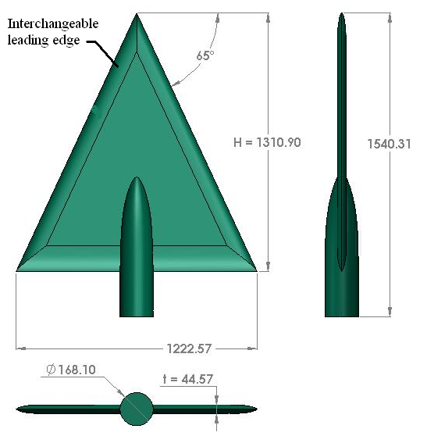

**Fig. 2.** UTM-LST delta wing VFE-2 profiles

Mat *et al*. [7] has performed a comprehensive flow visualization studies on blunt-edge delta wing. The primary vortex is developed at certain chordwise position and progress upstream with angle of attack; however there is no data in VFE-2 indicating that the vortex progressed up to the Apex region with angle of attack increases.

**3. Results**

*3.1 Pressure Distribution*

This section discusses the results obtained from the surface pressure measurement study. The effects of angle of attack, Reynolds number and leading edge bluntness are discussed in the next sub section.

*3.1.1 The effect of angle of attack*

The test configuration for this experiment is in Table 1. Nevertheless for the experiment at Reynolds number of 2×106, the angle of attack was limited to α = 23° only.

**Table 1**

The values of Reynolds number and velocity

|  |  |
| --- | --- |
| Reynolds number, Re | Velocity, V |
| 1×106 | 18 m/s |
| 2×106 | 36 m/s |

To differentiate the effects of Reynolds number, the experiments was also performed at two speeds of 18 m/s and 36 m/s that corresponding to 1×106 and 2×106 Reynolds number, calculated from Eq. 1 and summarize in Table 1.

$Re=\frac{ρVx}{μ}$ (1)

where the dynamic viscosity, μ, density of air, 𝜌 and length, *x* were taken as 1.846 ×10-5 kg/ms, 1.18 kg/m3 and 0.874 m respectively.

**4. Conclusions**

The experimental data of UTM-LST VFE-2 model at high angle of attack is presented here. More experiments are needed to verify this complicated flow topology.

**Acknowledgement**

This research was funded by a grant from Ministry of Higher Education of Malaysia (FRGS Grant R.J130000.7824.4X172).

**References (Chicago style) Minimum 15 references**

1. Xingcun Colin Tong, Advanced Materials and Design for Electromagnetic Interference Shielding (New York: CRC Press, 2016), 1-2.
2. Hae-Rim Kim, Kazushige Fujimori, Byoung-Suhk Kim and Ick-Soo Kim, "Lightweight Nanofibrous EMI Shielding Nanowebs Prepared by Electrospinning and Metallization," Composites Science and Technology 72, no. 11 (2012): 1233-1239.
3. K.L. Pickering, M.G. Aruan Efendy and T.M. Le, “A Review of Recent Developments in Natural Fibre Composites and Their Mechanical Performance,” Composites Part A: Applied Science and Manufacturing 83, (2016): 98-112.
4. Fadi Alkhatib, “ Techniques for Engine Mount Modeling and Optimization” (PhD Thesis, University of Wisconsin, 2013).
5. Wang Peng, Su Zhengtao, Lai Liangqing, Jiang Honggang and Wang Jinghe, "Engine Isolate Mount Elastomers" (PDF, 2015 International Conference on Structural, Mechanical and Material Engineering, Dalian, China, November 06-08, 2015).
6. David S. Mukooza, “Understand the Car Engine Mount,” Daily Monitor, Accessed February 7, 2020. https://www.monitor.co.ug/Business/Auto/Understand-car-engine-mount/688614-4388548-smy5eb/index.html.
7. Boris I. Yakobson and Phaedon Avouris, “Mechanical Properties of Carbon Nanotubes,” in *Carbon Nanotubes- Synthesis, Structure, Properties, and Applications*, ed. Mildred S. Dresselhaus, Gene Dresselhaus and Phaedon Avourisvol (Berlin: Springer, 2001): 287–327.
8. S. T. Mavhungu, E. T. Akinlabi, M. A. Onitiri and F.M.Varachia “Aluminum Matrix Composites for Industrial Use: Advances and Trends,” Procedia Manufacturing 7, (2017): 178–182.
9. Encyclopedia Britannica, s.v. “pressure,” accessed September 15, 2019, https://www.britannica.com/science/pressure.
10. Audit of the Federal Bureau of Prisons Annual Financial Statements Fiscal Year 2014, prepared by The Department of Justice (Washington, DC, 2014).
11. Michael J. Baker, The Marketing Book (Burlington, MA: Butterworth-Heinemann, 2002), 89, https://htbiblio.yolasite.com/resources/Marketing%20Book.pdf.

1. \* *Corresponding author.*

   *E-mail address: ali@gmail.com (Corresponding Author’s name)* [↑](#footnote-ref-1)